EXERCISE NO:11
DATE:24/11/2020
AIM:
To Write a Python program to find the greatest common divisor (gcd) of two integers using recursion.
PROGRAM:
def gcd(a,b):
if(b==0):
return a
else:
return gcd(b,a%b)
a=int(input("Enter first number:"))
b=int(input("Enter second number:"))
GCD=gcd(a,b)
print("GCD is:")
print(GCD)
LINK
http://103.53.53.18/mod/vpl/forms/submissionview.php?id=326&userid=1692
OUTPUT:
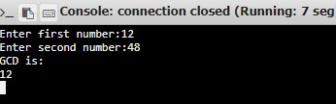
RESULT:
Hence , the Python program to find the greatest common divisor (gcd) of two integers using recursion is printed.

